Walchand College of Engineering, Sangli

Department of Computer Science and Engineering

Practical No. 5A (Batch – T7)

To design and develop web pages using HTML fundamental and formatting elements

Name: Saurabh Narayan Nagre

PRN: 2019BTECS00080

Coding Part: Added all the given requirements

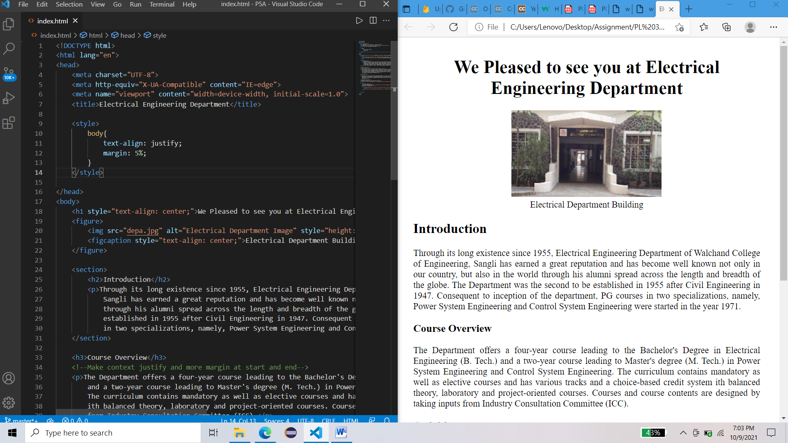

Website on local device from file location

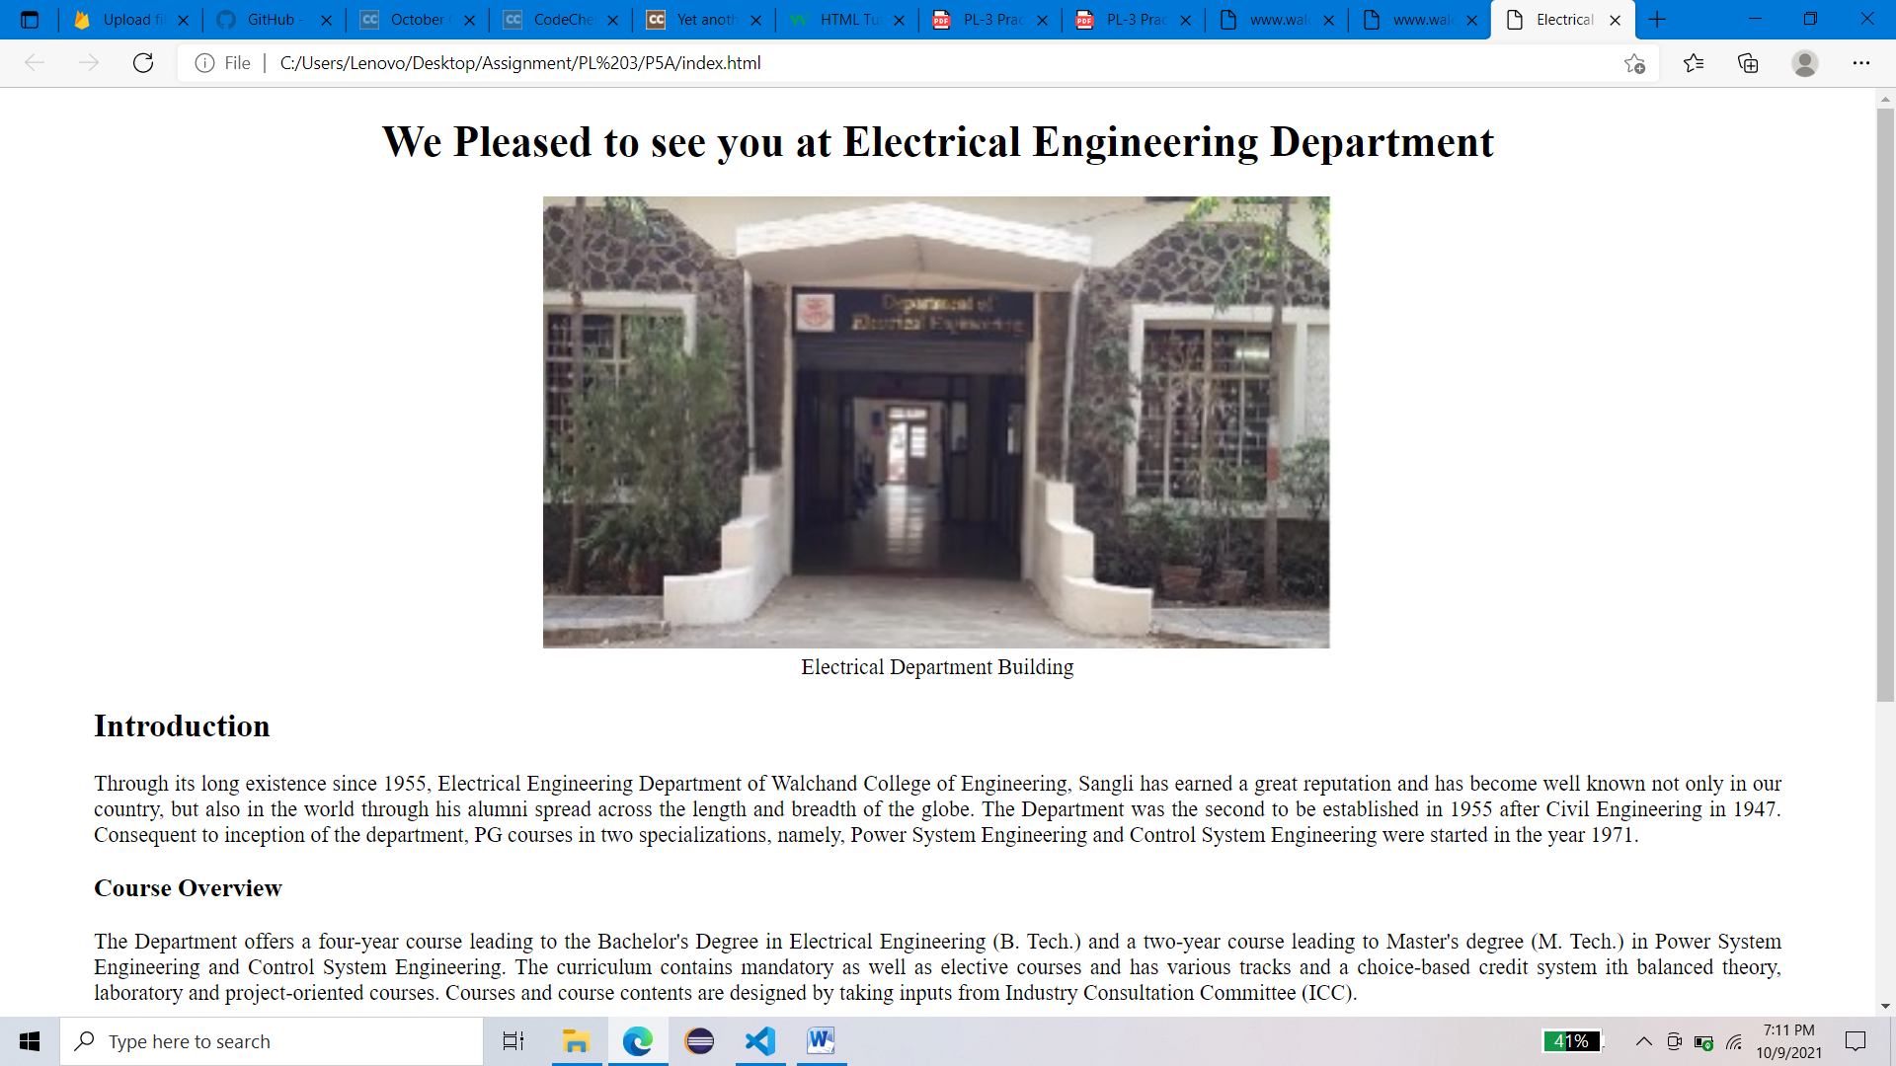

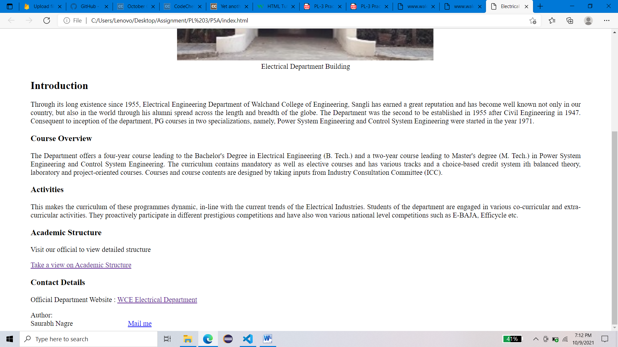

Using XAMPP for LAN server and local host serving

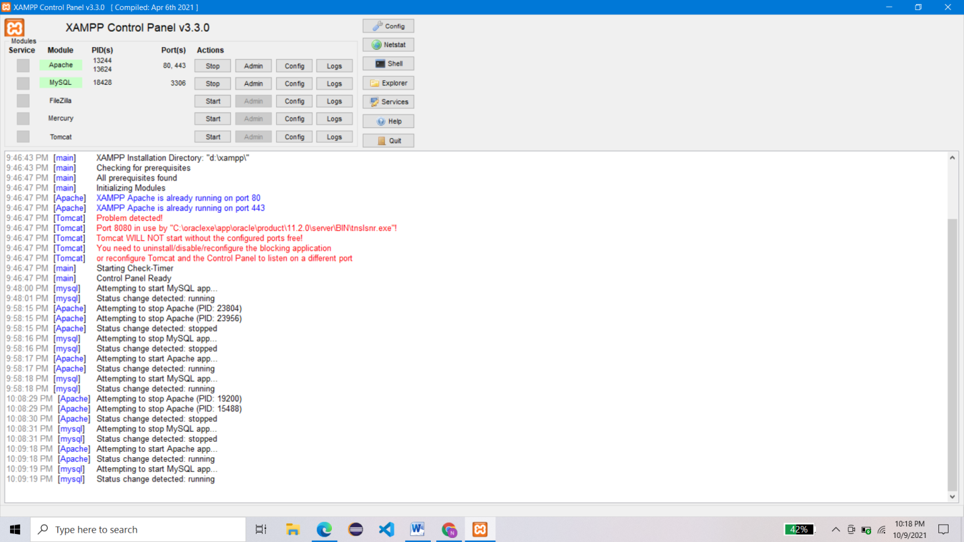

Website access using my Ip Address

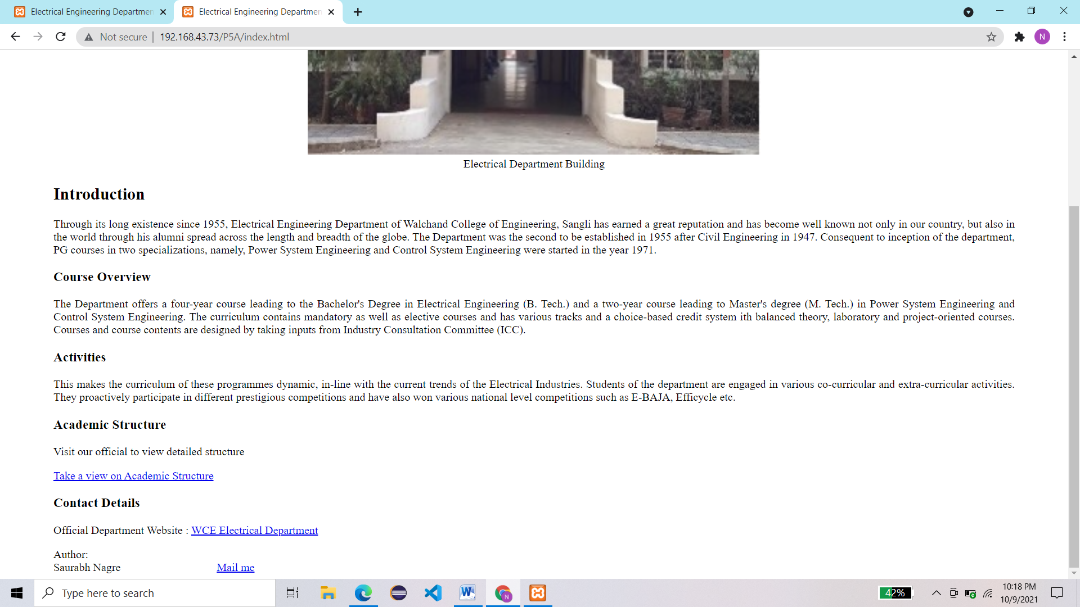

Using local host as server

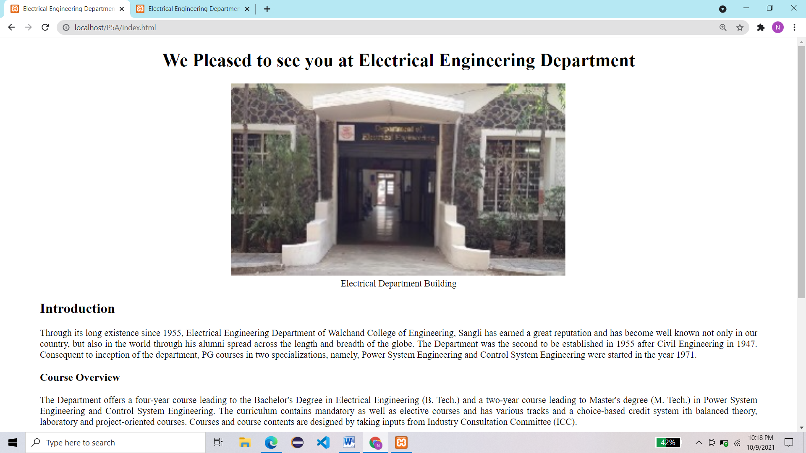

Git Hub Repo link:

<https://github.com/saurabh-nagre/PL3-Assignment>

Git pages link to access website:

<https://saurabh-nagre.github.io/PL3-Assignment/>

